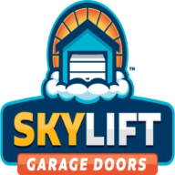

Skylift Garage Doors - Weatherproofing Checklist
https://skyliftgaragedoors.com/

⬚ Check & replace weatherstripping
⬚ Install threshold seal
⬚ Inspect insulation
⬚ Rust-proof tracks & rollers
⬚ Seal top & side jambs
⬚ Maintain opener seals
⬚ Clear gutters & roof runoff

Need help with garage door weatherproofing?
Give Skylift Garage Doors a call (844) 755-5149

